

FACULTY OF TECHNOLOGY AND ENGINEERING
DEVANG PATEL INSTITUTE OF ADVANCE TECHNOLOGY AND RESEARCH
DEPARTMENT OF INFORMATION TECHNOLOGY

A.Y. 2026-27 [SEMESTER 3]

LAB MANUAL

CEUE203: Object Oriented Programming


Practical 11

Serialization and NIO file operations
Problem Statement:
1. Save/load: serialize an object array and demonstrate that a transient field is not restored.
2. Log analyzer: count lines and keyword matches across files and report file sizes.
3. NIO tree report: walk a directory and write file names, sizes, and modification times.
Expected Output: The sample programs demonstrate the required behavior; see the captured console output below.

Solution:

LogAnalyzer.java
import java.io.IOException;
import java.nio.file.Files;
import java.nio.file.Path;
import java.nio.file.attribute.BasicFileAttributes;
import java.util.List;
public class LogAnalyzer {
public static void main(String[] args) throws IOException {
Path folder = Files.createTempDirectory("log-analyzer-");
try {
Files.write(folder.resolve("app.log"), List.of("INFO started", "ERROR disk full"));
Files.write(folder.resolve("auth.log"), List.of("INFO login", "ERROR denied"));
int lines = 0;
int matches = 0;
try (var paths = Files.list(folder)) {
for (Path file : paths.toList()) {
BasicFileAttributes attributes =
Files.readAttributes(file, BasicFileAttributes.class);
System.out.println(file.getFileName() + " bytes=" + attributes.size());
for (String line : Files.readAllLines(file)) {
lines++;
if (line.contains("ERROR")) matches++;
}
}
}
System.out.println("Total lines: " + lines);
System.out.println("Lines containing ERROR: " + matches);
} finally {
try (var paths = Files.list(folder)) {
for (Path file : paths.toList()) Files.deleteIfExists(file);
}
Files.deleteIfExists(folder);
}
}
}

NioTreeReport.java
import java.io.IOException;
import java.nio.file.Files;
import java.nio.file.Path;
import java.nio.file.attribute.BasicFileAttributes;
public class NioTreeReport {
public static void main(String[] args) throws IOException {
Path root = Files.createTempDirectory("tree-report-");
Path report = root.resolveSibling(root.getFileName() + "-report.txt");
try {
Files.createDirectories(root.resolve("subfolder"));
Files.writeString(root.resolve("first.txt"), "first file");
Files.writeString(root.resolve("subfolder").resolve("second.txt"), "second file");
StringBuilder output = new StringBuilder("File report for ").append(root)
.append(System.lineSeparator());
try (var paths = Files.walk(root)) {
for (Path path : paths.filter(Files::isRegularFile).toList()) {
BasicFileAttributes attributes =
Files.readAttributes(path, BasicFileAttributes.class);
output.append(path.getFileName()).append(" | ")
.append(attributes.size()).append(" bytes | ")
.append(attributes.lastModifiedTime()).append(System.lineSeparator());
}
}
Files.writeString(report, output);
System.out.println(Files.readString(report));
} finally {
try (var paths = Files.walk(root)) {
for (Path path : paths.sorted(java.util.Comparator.reverseOrder()).toList()) {
Files.deleteIfExists(path);
}
}
Files.deleteIfExists(report);
}
}
}

SerializationDemo.java
import java.io.IOException;
import java.io.ObjectInputStream;
import java.io.ObjectOutputStream;
import java.io.Serializable;
import java.nio.file.Files;
import java.nio.file.Path;
public class SerializationDemo {
private static final class Student implements Serializable {
private static final long serialVersionUID = 1L;
private final String name;
private transient String sessionToken;
Student(String name, String sessionToken) {
this.name = name;
this.sessionToken = sessionToken;
}
}
public static void main(String[] args) throws IOException, ClassNotFoundException {
Path file = Files.createTempFile("students-", ".dat");
try {
Student[] students = {new Student("Riya", "temporary-token")};
try (ObjectOutputStream output = new ObjectOutputStream(Files.newOutputStream(file))) {
output.writeObject(students);
}
try (ObjectInputStream input = new ObjectInputStream(Files.newInputStream(file))) {
Student[] loaded = (Student[]) input.readObject();
System.out.println("Loaded student: " + loaded[0].name);
System.out.println("Transient token: " + loaded[0].sessionToken);
}
} finally {
Files.deleteIfExists(file);
}
}
}

MiniBank Project Work:

MiniBank progress ? Practical 11
Completed: accounts can be serialized and restored; transaction logs append to files; ReportGenerator walks .log files with NIO and writes totals with file metadata.
Single project location: Java Programs\Minibank

Progressive source excerpts:

Minibank/src/main/java/minibank/service/StatePersister.java
package minibank.service;
import java.io.IOException;
import java.io.ObjectInputStream;
import java.io.ObjectOutputStream;
import java.nio.file.Files;
import java.nio.file.Path;
import minibank.model.Account;
public final class StatePersister {
private StatePersister() { }
public static void save(Account[] accounts, Path file) throws IOException {
Path parent = file.toAbsolutePath().getParent();
if (parent != null) Files.createDirectories(parent);
try (ObjectOutputStream output = new ObjectOutputStream(Files.newOutputStream(file))) {
output.writeObject(accounts);
}
}
public static Account[] load(Path file) throws IOException, ClassNotFoundException {
try (ObjectInputStream input = new ObjectInputStream(Files.newInputStream(file))) {
return (Account[]) input.readObject();
}
}
}

Minibank/src/main/java/minibank/service/TransactionLog.java
package minibank.service;
import java.io.IOException;
import java.nio.file.Files;
import java.nio.file.Path;
import java.nio.file.StandardOpenOption;
public final class TransactionLog {
private TransactionLog() { }
public static void append(Path file, String line) throws IOException {
Path parent = file.toAbsolutePath().getParent();
if (parent != null) Files.createDirectories(parent);
Files.writeString(file, line + System.lineSeparator(),
StandardOpenOption.CREATE, StandardOpenOption.APPEND);
}
}

Minibank/src/main/java/minibank/service/ReportGenerator.java
package minibank.service;
import java.io.BufferedReader;
import java.io.IOException;
import java.nio.file.Files;
import java.nio.file.Path;
import java.nio.file.attribute.BasicFileAttributes;
import java.util.regex.Matcher;
import java.util.regex.Pattern;
public final class ReportGenerator {
private static final Pattern TRANSACTION = Pattern.compile("^(DEPOSIT|WITHDRAW)\\s+(\\d+)$");
private ReportGenerator() { }
public static String generate(Path logsFolder, Path reportFile) throws IOException {
long deposits = 0;
long withdrawals = 0;
StringBuilder report = new StringBuilder("MINIBANK END-OF-DAY REPORT\n");
if (Files.isDirectory(logsFolder)) {
try (var files = Files.newDirectoryStream(logsFolder, "*.log")) {
for (Path file : files) {
BasicFileAttributes attributes =
Files.readAttributes(file, BasicFileAttributes.class);
report.append(file.getFileName()).append(" | ")
.append(attributes.size()).append(" bytes | ")
.append(attributes.lastModifiedTime()).append('\n');
try (BufferedReader reader = Files.newBufferedReader(file)) {
String line;
while ((line = reader.readLine()) != null) {
Matcher matcher = TRANSACTION.matcher(line.trim());
if (matcher.matches()) {
long amount = Long.parseLong(matcher.group(2));
if (matcher.group(1).equals("DEPOSIT")) deposits += amount;
else withdrawals += amount;
}
}
}
}
}
}
report.append("Total deposits: ").append(deposits).append('\n')
.append("Total withdrawals: ").append(withdrawals).append('\n');
Path parent = reportFile.toAbsolutePath().getParent();
if (parent != null) Files.createDirectories(parent);
Files.writeString(reportFile, report);
return report.toString();
}
}

Output Screenshot:
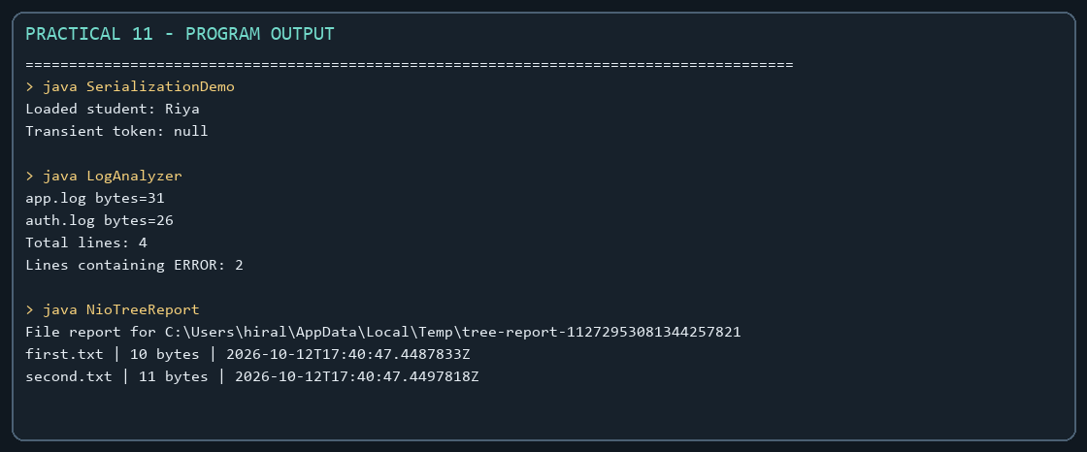
Captured from the compiled practical programs.

